The MSME Digital Gateway is LIVE!
The MSME Digital Gateway is a one platform creating endless opportunities for Ghanaian businesses.
Read More

The MSME Digital Gateway is now live - a transformative digital platform designed to help Micro, Small and Medium Enterprises (MSMEs) in Ghana start, grow, scale, and compete locally and globally.
Developed through a partnership between the Ghana Enterprises Agency (GEA), the lead public institution supporting MSME growth in Ghana, the Ghana-India Kofi Annan Centre of Excellence in ICT (GI-KACE) as the technical partner, and the United Nations Development Programme (UNDP), with funding support from the Joint SDG Fund, the MSME Digital Gateway was created to address the real challenges faced by MSMEs, including limited access to reliable business information, funding opportunities, market access, and digital tools.
Whether you are a start-up, a growing business, a woman-led enterprise, or a young entrepreneur looking to scale, the Gateway gives you access to the resources and support you need — all in one place.
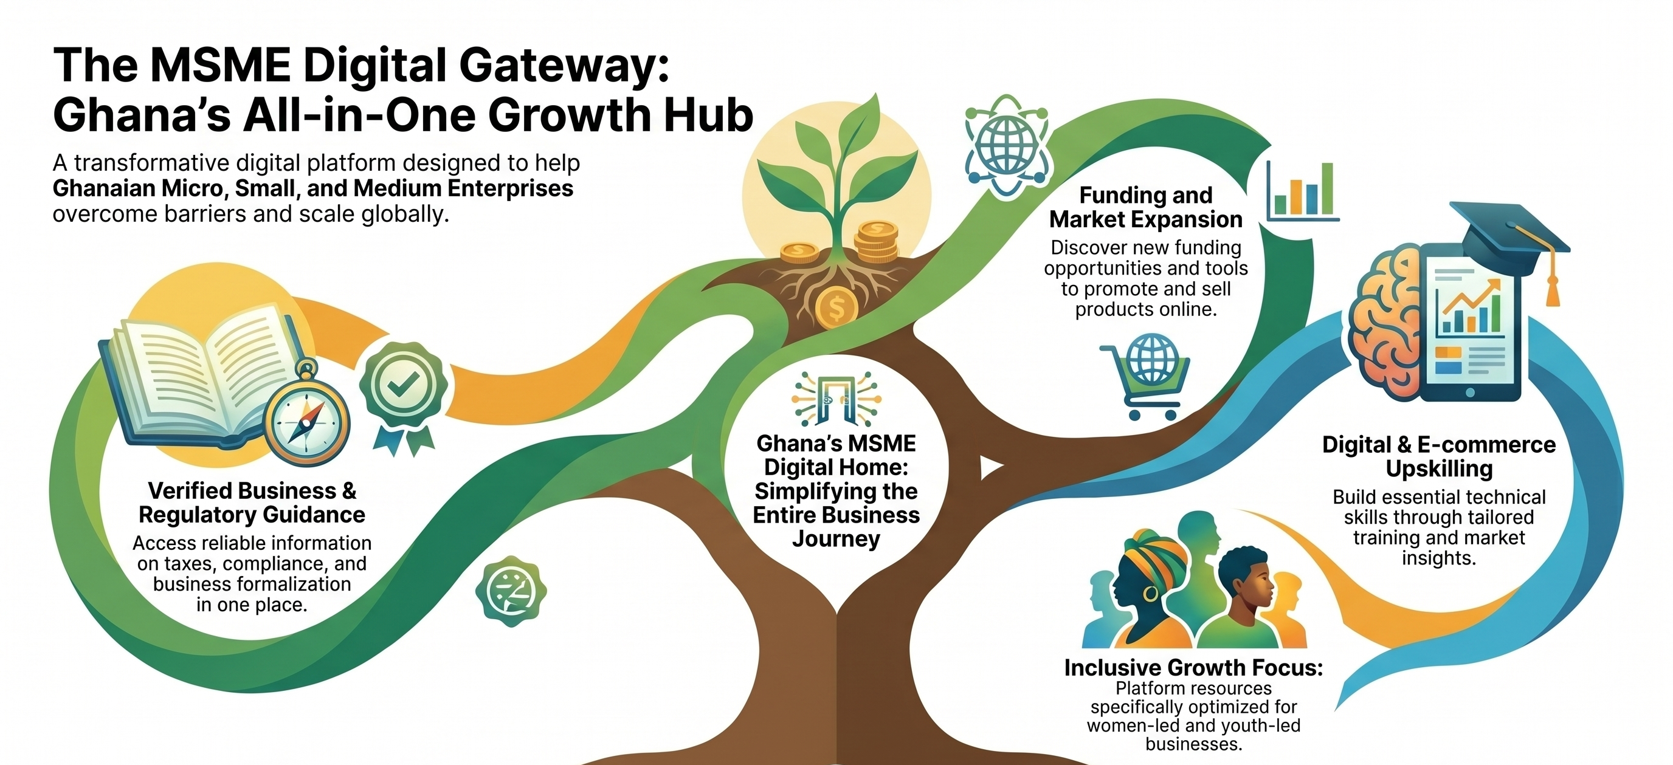

Through the Gateway, you can:
- Access verified business and regulatory information
- Discover funding and growth opportunities
- Learn about taxes, compliance, and business formalization
- Build your digital and e-commerce skills
- Promote and sell your products online
- Connect with service providers and business support institutions
- Access tools, training, and market insights tailored to your business needs
Built through extensive research and stakeholder consultations, the platform is designed to simplify the business journey for MSMEs across Ghana especially women-led and youth-led businesses, which represent a significant portion of the country’s enterprise ecosystem.
The gateway is not just any platform – It is Ghana’s digital home for MSME growth.
Start exploring today and unlock new opportunities for your business.
The MSME Digital Gateway — Empowering Businesses. Connecting Opportunities. Driving Growth.

